**Heart Attack Possibility Prediction**

**Milestone: Data exploration and preprocessing**

Group 18

Student 1 Karan Paresh

Student 2 Tianyu Yang

857-294-7660 (Tel of Karan Paresh)

617-368-0332 (Tel of Tianyu Yang)

[samani.k@northeastern.edu](mailto:samani.k@northeastern.edu)

[yang.tianyu@northeastern.edu](mailto:yang.tianyu@northeastern.edu)

**Percentage of Effort Contributed by Student 1: 50%**

**Percentage of Effort Contributed by Student2: 50%**

**Signature of Student 1: Karan Paresh**

**Signature of Student 2: Tianyu Yang**

**Submission Date: 10/4/2021**

**Data exploration and visualization**

**Countplots:**

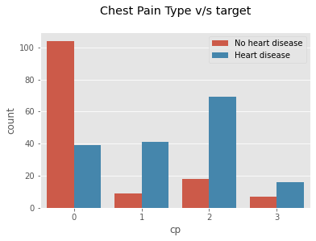

*figure 5:*

There are four types of chest pain, asymptomatic, atypical angina, nonanginal pain and typical angina. Most

of the Heart disease patients are found to have atypical anginal and non anginal chest pain and very few have

typical angina. As the severity increases the number of people who are suffering from heart disease are more

compared to those who are not suffering from heart disease. These group of people might show symptoms like

indigestion, flu or a strained chest muscle.Heart attack, involves, blockage of blood flow to your heart and

possible damage to the heart muscle.

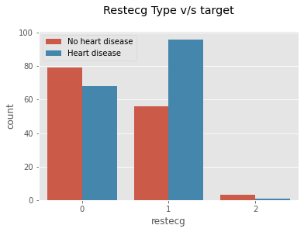

*figure 6:*

There are three types of restecg states Value 0: normal, Value 1: showing probable or definite left ventricular hypertrophy by Estes’ criteria, Value 2: having ST-T wave abnormality (T wave inversions and/or ST elevation or depression of > 0.05 mV).As the severity increases the number of people who are suffering from heart disease are more compared to those who are not suffering from heart disease.The result shows that people who are suffering from the heart disease have higher ecg value and maximum people has 'value' = 1 and very few suffering from heart disease has ‘value’=2.

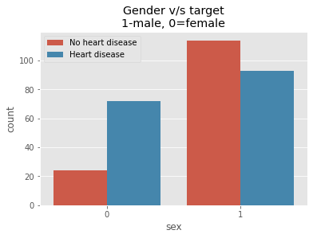

*figure 7:*

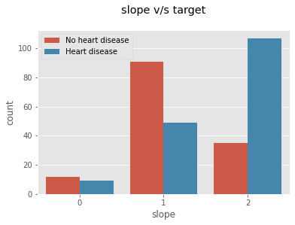According to this dataset males are more susceptible to get Heart Disease than females. Men experience heart attacks more than women. Sudden Heart Attacks are experienced by men between 70% — 89%. Woman may experience a heart attack with no chest pressure at all, they usually experience nausea or vomiting which are often confused with acid reflux or the flu.

*figure 8:*

The slope of the peak exercise ST segment has three values 0: down-sloping; 1: flat; 2: upsloping, when the value is 0 and 2 the possibility of heart attack is high and when it is 1 the chances of getting heart attack is less. The graph shows the people who are suffering from the heart disease has the slope value of either 0 or 2 and maximum people who do not suffer from the heart disease has the slope value 1.

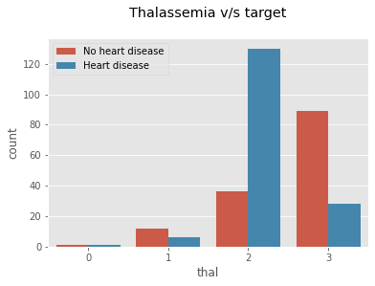

*figure 9:*

A blood disorder called thalassemia, it has discrete values Value 1: normal blood flow Value 2: fixed defect (no blood flow in some part of the heart) Value 3: reversible defect (a blood flow is observed but it is not normal).The graph shows that people who are suffering from heart disease has a defect value 2 and 3 and those arent suffering from heart disease has a value 1 and 3.

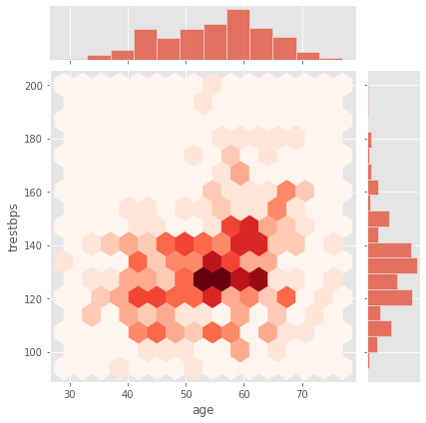**Jointplots:**

*figure 10:*

Joint plots in seaborn helps us to understand the trend seen among two features. As observed from the above plot we can see that most of the Heart diseased patients in their age of upper 50s or lower 60s tend to have trestbps higher than 120mmHg.

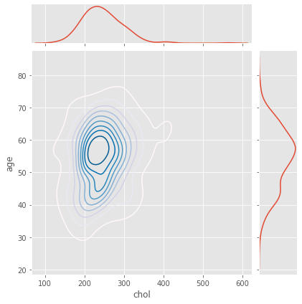

*figure 11:*

Joint plots in seaborn helps us to understand the trend seen among two features. As observed from the above plot we can see that most of the Heart diseased patients in their age of upper 50s or lower 60s tend to have Cholesterol between 200mg/dl to 300mg/dl.

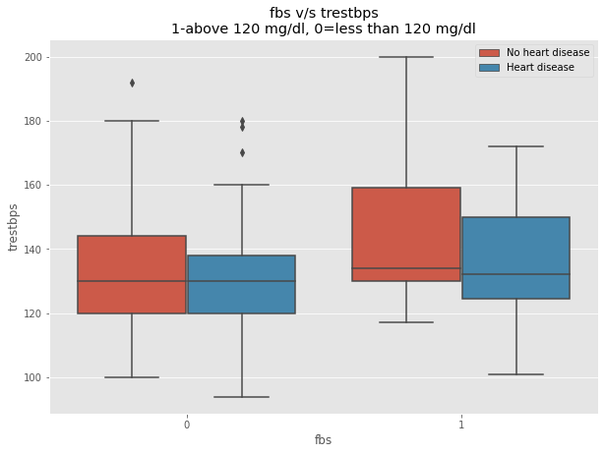**Boxplot:**

*figure 12:*

The boxplot shows that the people who are diabetic (fasting blood sugar) has higher resting blood pressure which concludes that these group of people tend to have higher chances of having heart disease.

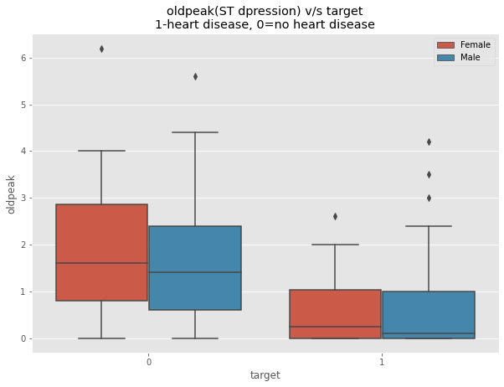

*figure 13:*

The boxplot shows that low ST Depression (oldpeak) yields people at greater risk for heart disease. While a high ST depression is considered normal & healthy.If the range is lesser than 1.5 its a high risk and if it is greater than 1.5 the person is at low risk of getting a heart attack.